Lab Notebook of T.Perez | CSUN 108484650 | COMP490L | CTL-DYnAmiCs

10-4-18

Spoke with prof Shapiro re informal mentoring of project, and said he’ll email prof Dewey.

[Mentioned to prof Dewey about the above. ]

It was suggested by prof S that a glossary might be helpful if needed on paper.

“Venue” was discussed. The math’ venue was chosen. *

* Since this is the case now, a toned-down version of the Contributions page should be

re-written.

10-5-18

Sent prof D and prof S ;

https://github.com/citationdude/NK-Cell-Simulator link

10-6-18

A toned-down version of the Contributions page was resubmitted. It also was probably an unacceptable format since it included an abstraction of the paper’s future abstract to sort of

“guide in” a pathway (an exposition to the “storyline”) to a somewhat new concept to those whom may review the paper.

10-7-18

**Plan of execution** for reviving and amending older model ‡ ; ; ;

Review prior notes.

Re-read Killer Cell Dyn – Wodarz ‡

10-8-18

LTG (long term goal) graphic;

Conceptual

correlations

Review all Hao Yuan Kueh material

Review

all Wodarz material

WODARZ-KUEH CORRELATION MDL

Mathematical

correlations

Current (10-8-18)

Wodarz mdl.

(Get Qt Creator version working)

Staged Wodarz model

Staged Kueh model

Get solutions via ODE tool (recommended by Prof Shapiro)

Determine Kueh

variables. Using Wodarz dynamic equations*. Setup*.

Implement o/p metrics

Test both versions

10-9-18 [ADD to Paper/ Introduction - TBA]

It must be considered that there exists certain mechanisms that are not included for this research. A relatively important one is transcriptase in terms of it’s proofreading type capabilities.

Since the Wodarz model is LCMV virus based, (key word virus), and his experiments are CD4 centered, many or most viruses are CD4 impaired , as are many cancers. Regarding CD4/CTL, there can be a valid correlation between certain cancers and certain viruses like LCMV. It just happens that the mouse virus (LCMV) is a good model. A well known virus of course the the HIV virus. Here, like cancers being of the retrovirus type, HIV is also a transcriptase problem (reverse transcriptase mechanism). [Wodarz 2007]. Also behaving differently from each other, in terms of immunology, the HIV and HCV are CD4 problematic.

New new discovery has been published regarding this, (ie the concept of [basically] way too many variables that can possibly determine viral or cancerous efficacy). As reported by the Cancer research UK, [cited by James Gallagher – Health and Science correspondent, BBC News – 12, Apr 2018], [sic]the Francis Crick Institute developed a way to analyze a cancer’s history to predict its future. One cancer could kill quickly while a patient with a seemingly identical cancer could live for decades after treatment. They state that [and knowing that , sic] as cancers grow and evolve, they become more mutated and, eventually, different parts of the tumor start to mutate in different ways.

ie to say, this phenomenon is so prevalent, they are intent on pinning down the root causes for this occurance.

10-12-18

OSX upgraded from 10.10.5 to High Sierra 10.13.6 by Dino Computers. This allows ;

• IDE Qt Creator CTL_Dyn_5 to work. (∞)

• Parallels to be upgraded.

• MS Virtual Studio with Q# (quantum sim’ library) to work for OSX.

(∞) The initial runtime Wodarz pathway GUI is now used. Metrics also now output upon

successful pgm termination.

10-13-18 [ADD to Paper/ 1st ¶ of Introduction – TBA (re validation of LCMV Wodarz §7.2 p103)]

[sic]”LCMV infection is an ideal system to test mathematical predictions. The occurance of CTL-induced pathology resulting from the killing of infected cells is clearly documented with LCMV. In addition, viral and host parameters can be carried easily.”

[Wodarz p100]Several or many concepts are under debate among researchers eg virus vs CTL contributions to tissue damage in the common cold, also eg, [Wodarz p155[Levy]]the mechanism at which CAF (CTL secreted antiviral factor) stops viral production of viral particles by host cells in HIV.

Added to this, are other nuances of immunity, eg, [Wodarz p125[Arnaout/Nowak 2000]] B-cells competition with CTL proliferations.

The point is that even if (by some miracle) this paper can be construed as somewhat useful beyond simply graphically depicting Wodarz-Kueh dynamics, it will be debated at best. (I will then take this as a compliment).

Careful with §7 (p99->) Control Virus CTL-Induced Pathology.

[Written lab’ notes below]

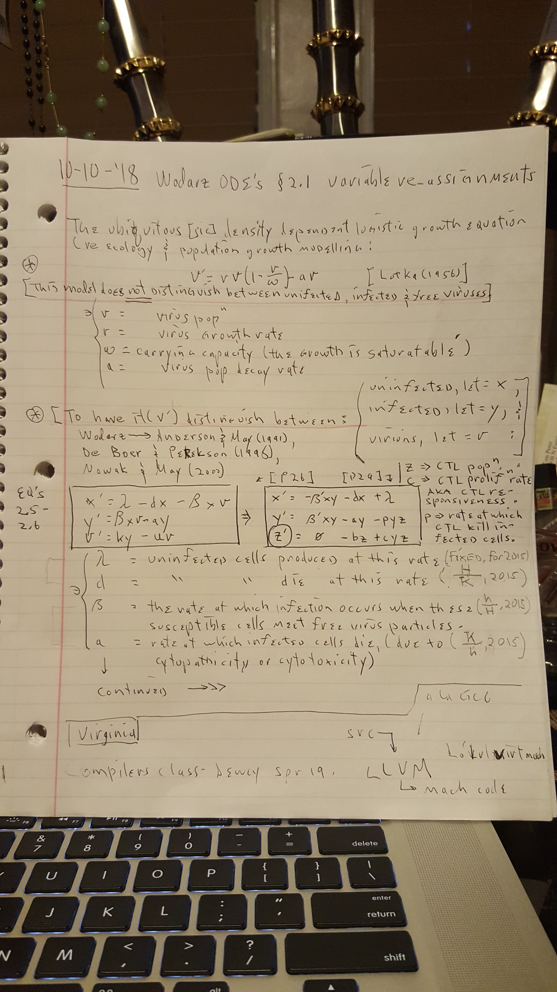

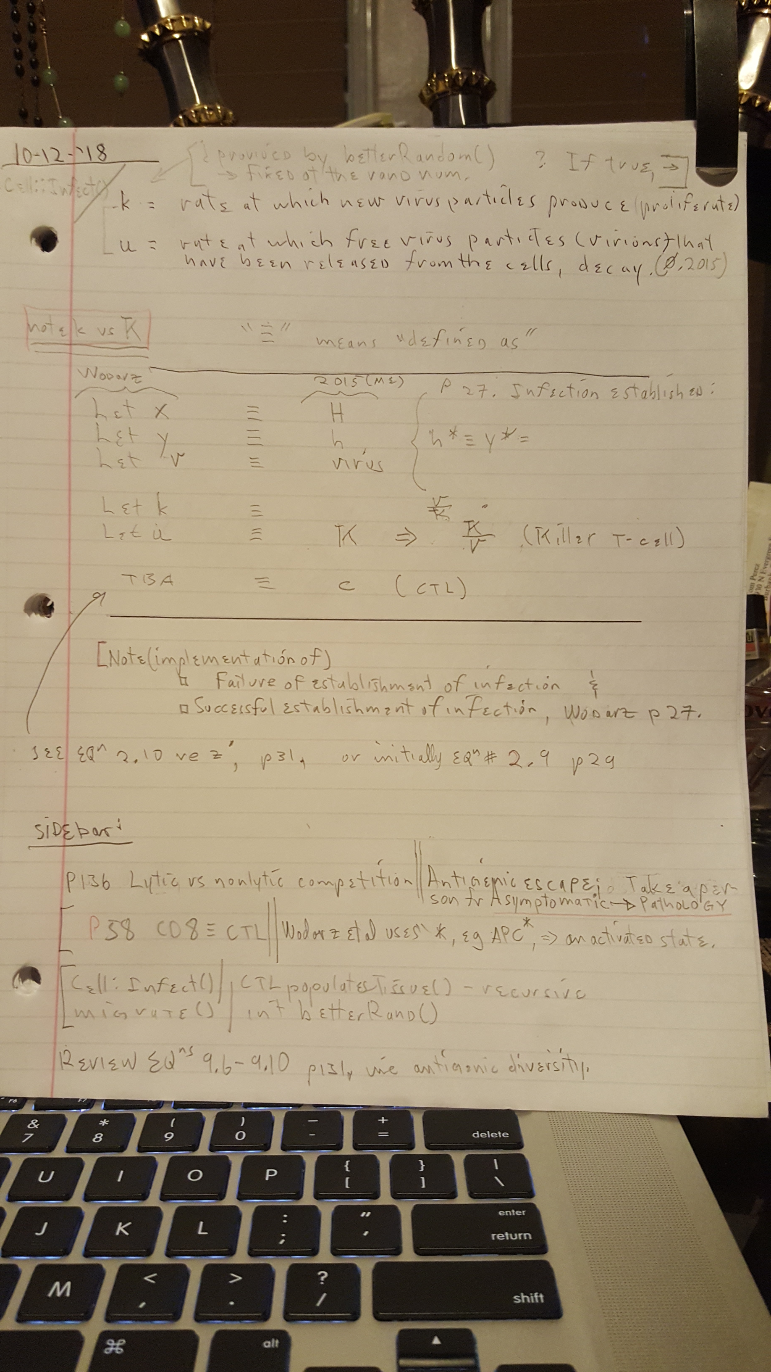

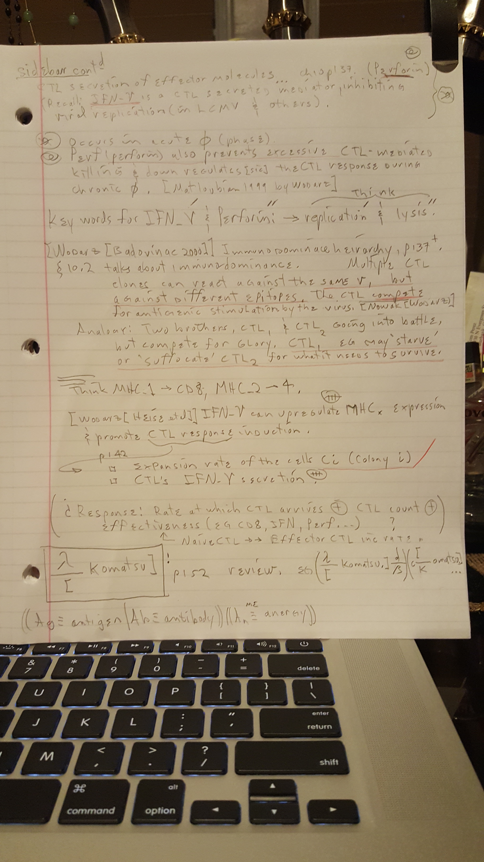

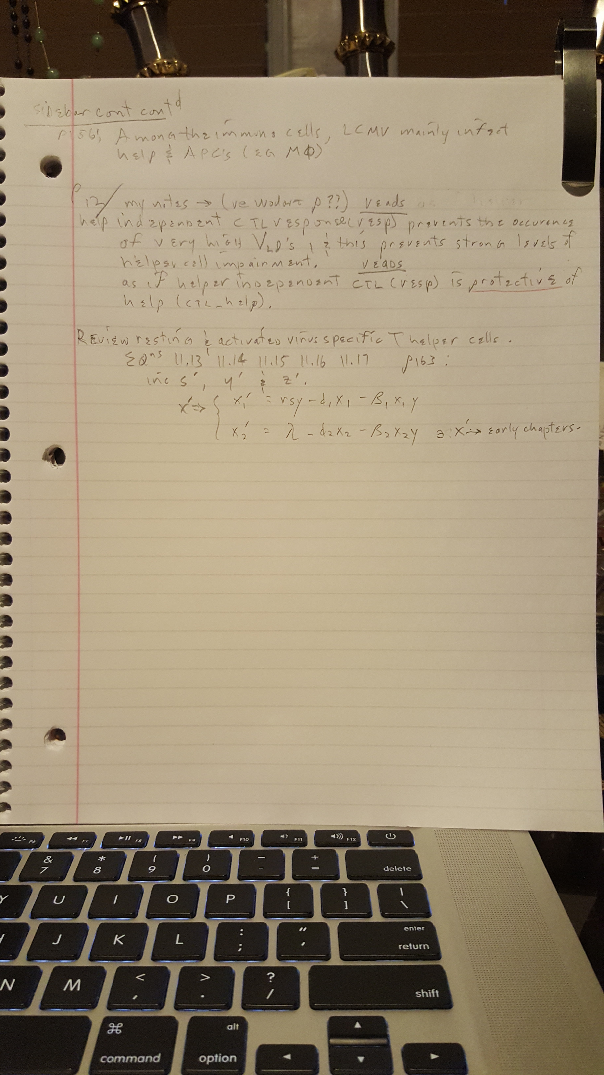

10-18-18

An enhanced awareness of the above Plan of Execution’s LTG (long term goal) graphic

is established.

Therefore the IMMEDIATE plan is to;

1) “Intelligently scan” the remaining portion of Wodarz. (Notes and summary completed).

A) Observe any dyn’ equations* that may be able to link or help link Wodarz to Kueh.

B) re Caltech Research Posting , investigate Kueh team member Kenneth Ng (Cal Poly’)

for any help*.

Search ResearchGate.

2) Read Dr. Kueh’s \*\***Asynchronous Combinatorial Action of Four Regulatory Factors Activates**

**BCL11b for T Cell Commitment,** (&/or Kenneth Ng’s work).

[Note] Caltech Research Posting 7-15-16 differs in flow of the 4 PT’s (protein) wrt Bcl11b from what Kueh’s paper** describes.

3)

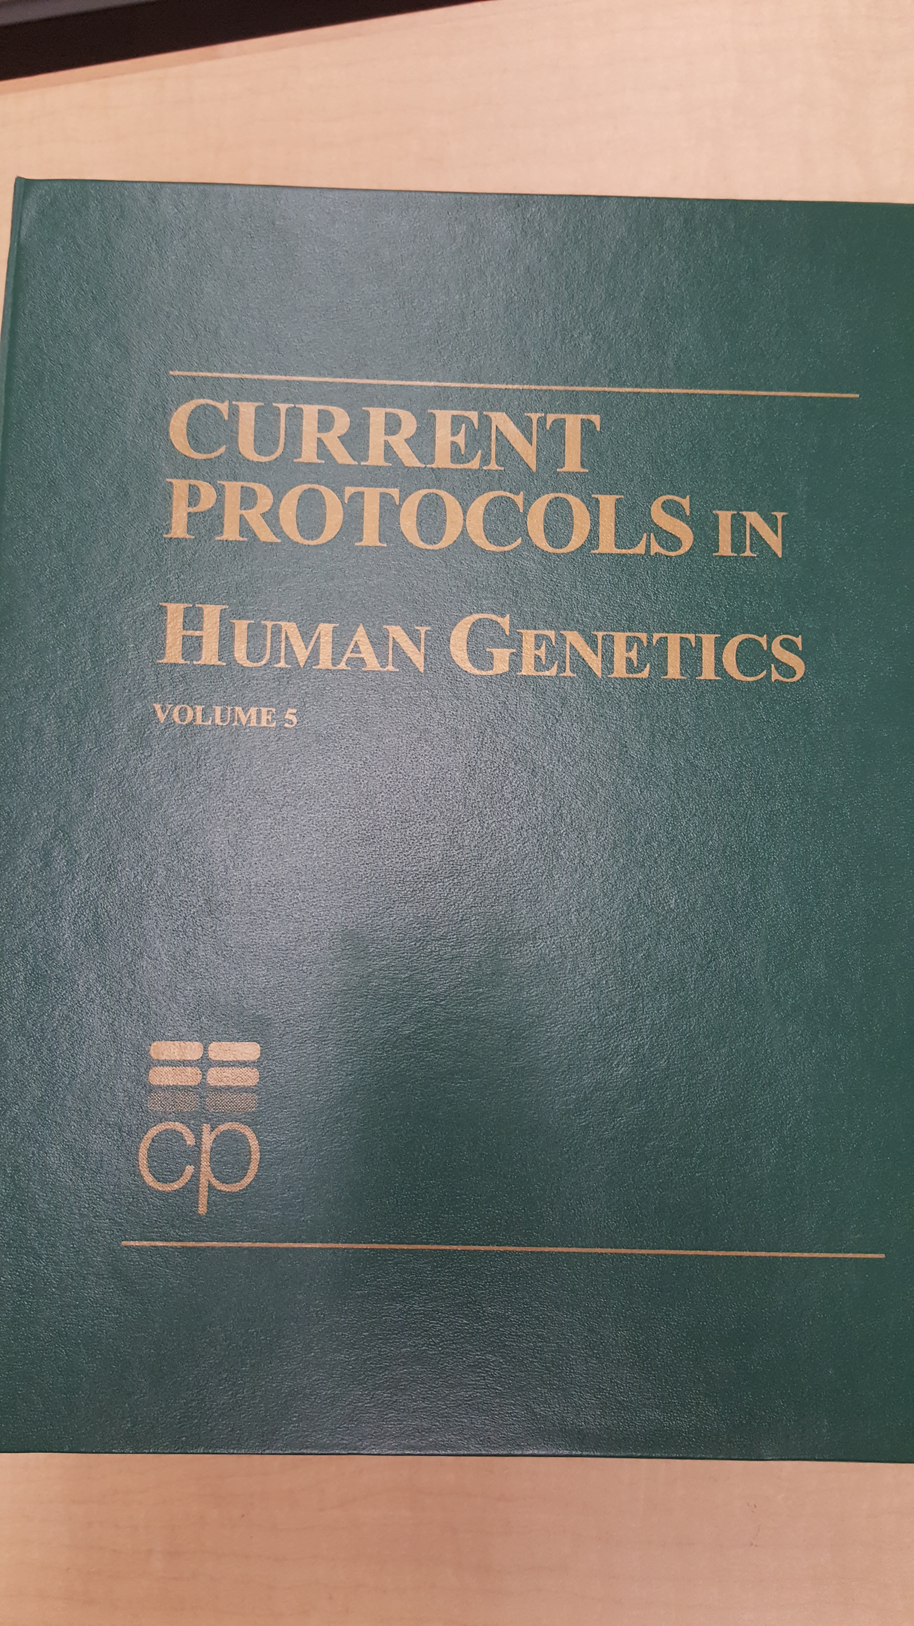

“Read” over sections 1 and 10.

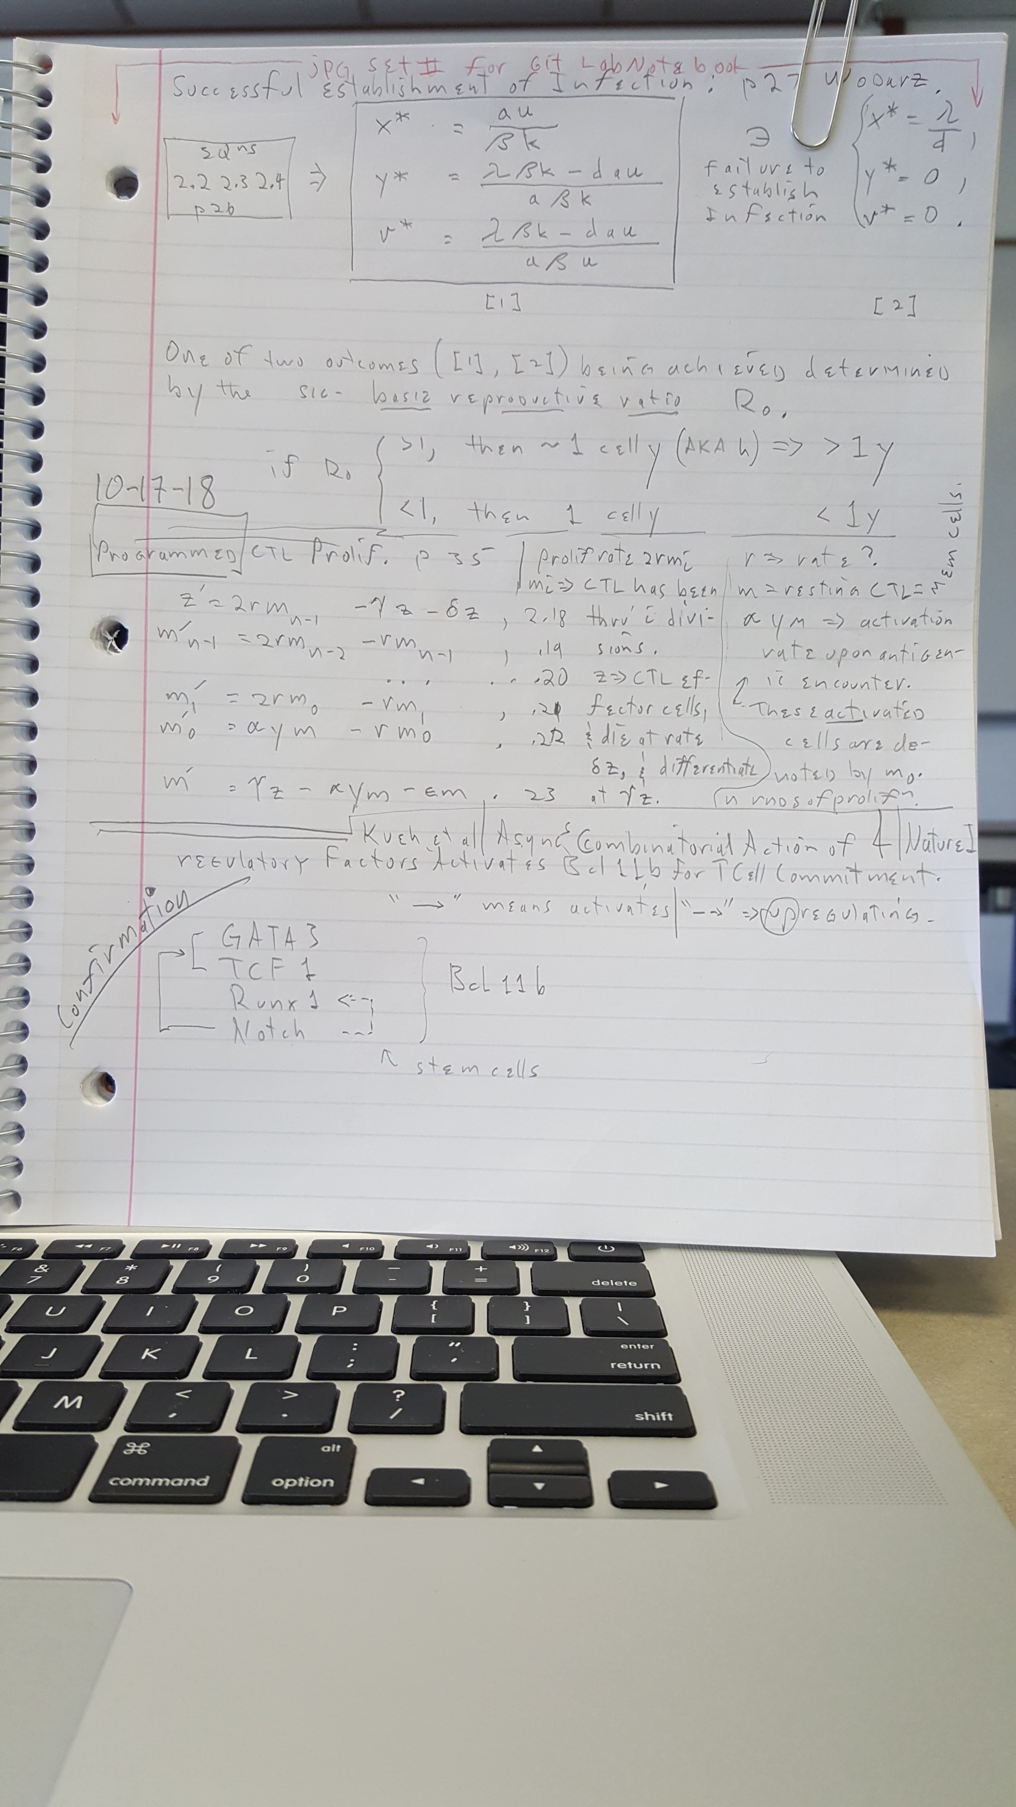

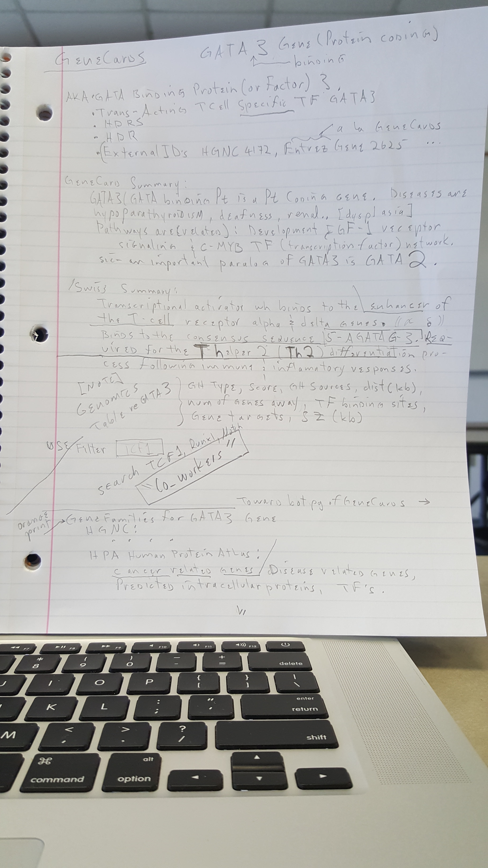

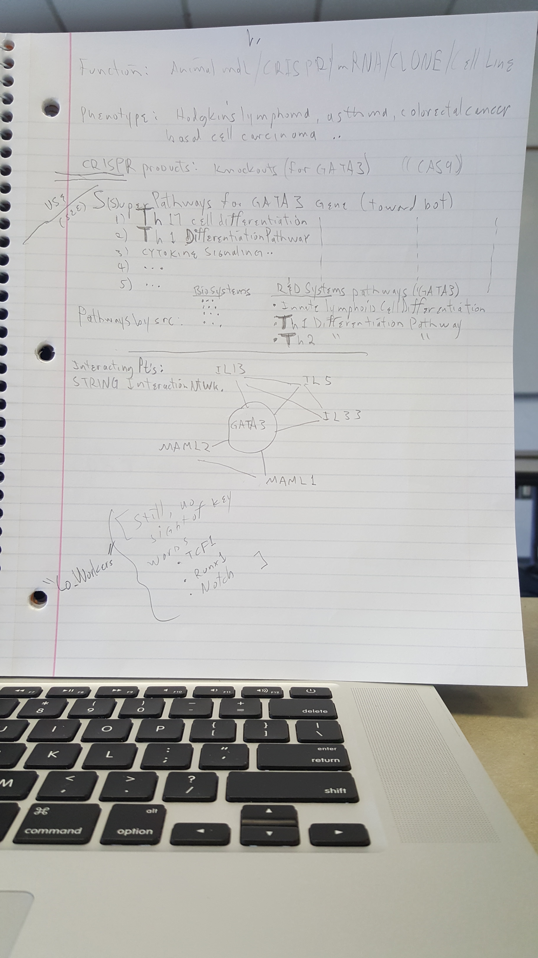

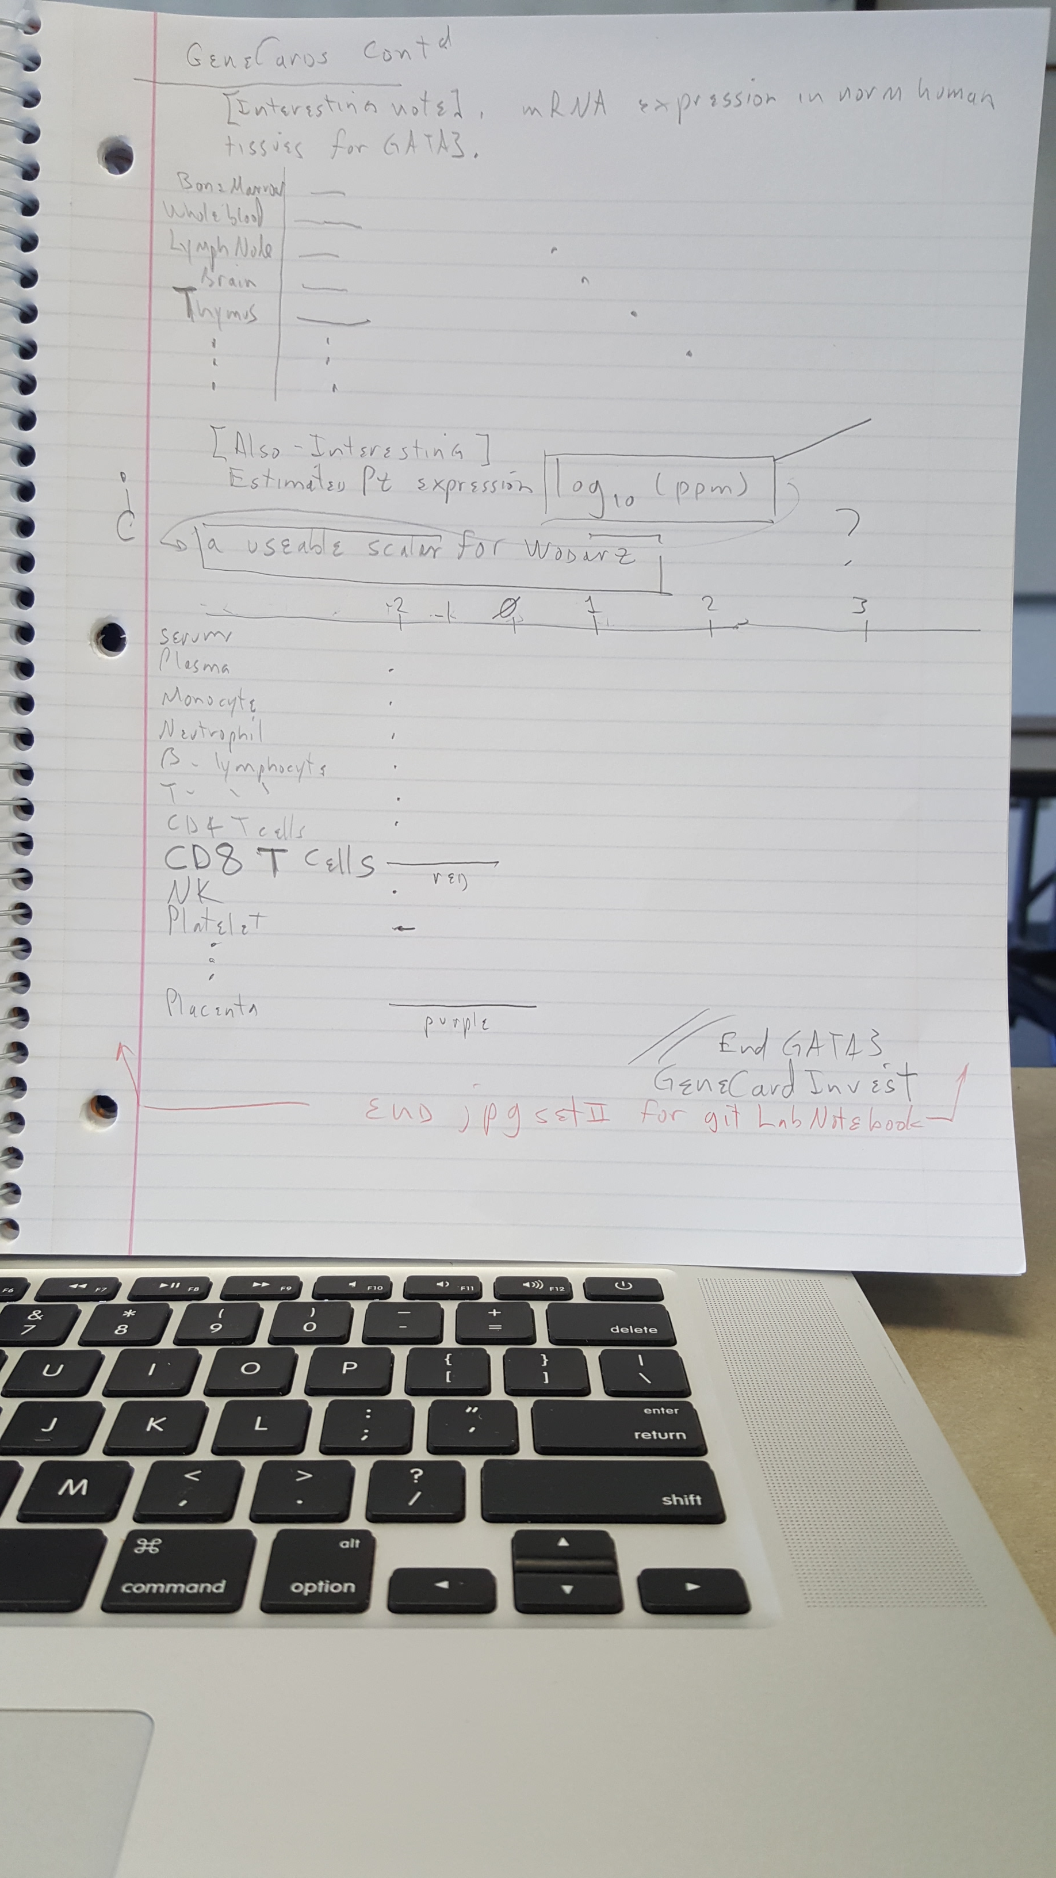

[end 10-18-18 log]